EXPERIMENTS

NAME:BHARANI DHARAN S
REG NO:192424141
COURSE CODE:DSA0602 DATA HANDLING AND VISUALIZATION

Set 7 – Customer Demographics Analysis

Customer ID | Age | Gender | Income (in $)
1 | 28 | Female | 50000
2 | 35 | Male | 60000
3 | 42 | Female | 75000

QUESTION 1
Create a bar chart to visualize the distribution of customer ages. Label the axes and title the chart.

AIM
To create a bar chart to visualize the distribution of customer ages using R.

PROCEDURE
- Create the customer demographics dataset.
- Store the Customer ID and Age values.
- Use the barplot() function to create the bar chart.
- Label the X-axis and Y-axis.
- Add a suitable title.
- Display the chart.

CODE

customer <- data.frame(
Customer_ID = c(1, 2, 3),
Age = c(28, 35, 42),
Gender = c("Female", "Male", "Female"),
Income = c(50000, 60000, 75000)
)

barplot(
customer$Age,
names.arg = customer$Customer_ID,
xlab = "Customer ID",
ylab = "Age",
main = "Distribution of Customer Ages"
)
OUTPUT

RESULT
Thus, the bar chart representing the distribution of customer ages was successfully created.

QUESTION 2
Generate a pie chart to represent the distribution of customers by gender.

AIM
To create a pie chart representing the distribution of customers based on gender.

PROCEDURE
- Create the customer demographics dataset.
- Count the number of customers in each gender.
- Use the table() function.
- Use the pie() function to create the pie chart.
- Add a suitable title.
- Display the chart.

CODE
customer <- data.frame(
Customer_ID = c(1, 2, 3),
Age = c(28, 35, 42),
Gender = c("Female", "Male", "Female"),
Income = c(50000, 60000, 75000)
)

gender_count <- table(customer$Gender)

pie(
gender_count,
labels = names(gender_count),
main = "Customer Distribution by Gender"
)
OUTPUT

RESULT
Thus, the stacked bar chart was successfully created to represent product quantities within different categories.

QUESTION 3
Build a table to show the demographic information for each customer. Label the table elements.

AIM
To create a table displaying the demographic information of each customer.

PROCEDURE
- Create the customer demographics dataset.
- Enter Customer ID, Age, Gender and Income.
- Assign suitable column names.
- Display the dataset as a table.

CODE
customer <- data.frame(
Customer_ID = c(1, 2, 3),
Age = c(28, 35, 42),
Gender = c("Female", "Male", "Female"),
Income = c(50000, 60000, 75000)
)

print(customer)

OUTPUT

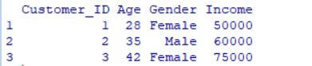

RESULT
Thus, the scatter plot was successfully created to analyze the relationship between product price and quantity available.
QUESTION 4

Develop an interactive dashboard combining the bar chart, pie chart, and the table for interactive exploration of customer demographics.

AIM
To develop an interactive customer demographics dashboard using R Shiny by combining a bar chart, pie chart and customer information table.

PROCEDURE
- Create the customer demographics dataset.
- Load the Shiny package.
- Create a user interface containing the bar chart, pie chart and table.
- Create the server section to generate the charts and table.
- Add a gender filter for interactive exploration.
- Run the Shiny application.
- View the dashboard in the browser.

CODE
library(shiny)

customer <- data.frame(
Customer_ID = c(1, 2, 3),
Age = c(28, 35, 42),
Gender = c("Female", "Male", "Female"),
Income = c(50000, 60000, 75000)
)

ui <- fluidPage(
titlePanel("Customer Demographics Dashboard"),

sidebarLayout(
sidebarPanel(
selectInput(
"gender",
"Select Gender:",
choices = c("All", "Female", "Male")
)
),

mainPanel(
plotOutput("agePlot"),
plotOutput("genderPlot"),
tableOutput("customerTable")
)
)
)

server <- function(input, output) {

filteredData <- reactive({
if (input$gender == "All") {
customer
} else {
customer[customer$Gender == input$gender, ]
}
})

output$agePlot <- renderPlot({
data <- filteredData()

barplot(
data$Age,
names.arg = data$Customer_ID,
xlab = "Customer ID",
ylab = "Age",
main = "Distribution of Customer Ages"
)
})

output$genderPlot <- renderPlot({
data <- filteredData()

gender_count <- table(data$Gender)

pie(
gender_count,
labels = names(gender_count),
main = "Customer Distribution by Gender"
)
})

output$customerTable <- renderTable({
filteredData()
})
}

shinyApp(ui = ui, server = server)

OUTPUT
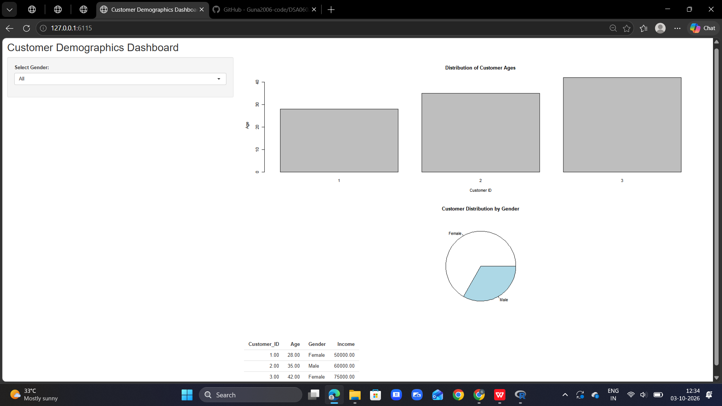

RESULT
Thus, an interactive customer demographics dashboard containing a bar chart, pie chart and demographic table was successfully created using R Shiny.

